##### Project report on

**VACCINE HANDLING SYSTEM**

A Dissertation submitted to JNTU Hyderabad in partial fulfillment of the academic requirements for the award of the degree.

**Bachelor of Technology**

**In**

**Computer Science and Engineering**

Submitted by

##### D.Keerthi (19H51A0538)

##### E.Sanjupriya (19H51A0539)

##### K.Pavan (19H51A0544)

Under the esteemed guidance of

(Ms. Preety Singh)



**Department of Computer Science and Engineering**

**CMR COLLEGE OF ENGINEERING & TECHNOLOGY**

[An Autonomous Institution under UGC & JNTUH,Approved by AICTE , Permanently Affiliated to JNTUH, Accredited by NBA.]

2019-2023

**CMR COLLEGE OF ENGINEERING & TECHNOLOGY**

KANDLAKOYA, MEDCHAL ROAD, HYDERABAD – 501401

**DEPARTMENT OF COMPUTER SCIENCE AND ENGINEERING**



#### CERTIFICATE

This is to certify that the mini project-1 report entitled **“VACCINE HANDLING SYSTEM”** being submitted by **D.Keerthi(19H51A0538), E.Sanjupriya(19H51A0539), K.Pavan(19H51A0544),** in partial fulfillment for the award of **Bachelor of Technology** in **Computer Science and Engineering** is a record of bonafide work carried out his/her under my guidance and supervision.

###### The results embodies in this project report have not been submitted to any other University or Institute for the award of any Degree.

**Ms.Preety Singh**

**Asst.Professor**

**Dept. of CSE**

**Dr. K.Vijaya kumar**

**Professor and HOD**

**Dept. of CSE**

#### ABSTRACT

As we all know COVID-19 phase-2 has drastically affected the people with it’s effects when compared to last year/phase. So,Now it is our responsibility to stop the spread of this COVID-19 by decreasing the gathering for people in the locality and maintaining the social distancing and few other requirements. (**AREA/LOCALITIES:** Tadband, Bowenpally, Amberpet, Chaitanyapuri, Nampally). So,we came up with an idea of **‘’VACCINE HANDLING SYSTEM’’** where this project will help the admins who are managing the vaccines of COVID-19 by decreasing the people in vaccination center by speed data entry and smart working. We are using C++ file coding language in designing of code. To handle our project we are using CodeBlocks platform and to handle the vaccine data we are using C++ file handling system environment . Hence we think that our project will be helpful in this present scenario and decreases the COvID-19.

**TABLE OF CONTENTS**

|  |  |  |  |  |  |
| --- | --- | --- | --- | --- | --- |
| **CHAPTER NO** | **TITLE** | | | | **PAGE NO** |
|  | **ABSTRACT** | | | |  |
| **1** | **INTRODUCTION** | | | | 1 |
|  | 1.1 | | scope | | 1 |
|  | 1.2 | | objectives | | 1 |
| **2** | **BACKGROUND WORK** | | | | 2-3 |
|  | 2.1 | | Existing systems | | 2 |
|  | 2.2 | | Gaps in existing systems | | 3 |
| **3** | **PROPOSED SYSTEM** | | | | 4-5 |
|  | **3**.1 | | System design and description | | 4 |
|  |  | | 3.1.1 | Advantages of proposed system | 4 |
|  | 3.2 | | Modules Description | | 4-5 |
|  | 3.3 | | Requirement specifications | | 5 |
|  |  | | 3.3.1 | Hardware Requirements | 5 |
|  |  | | 3.3.2 | Software Requirements | 5 |
|  | 3.4 | | System Architecture | | 6 |
| **4** | **UML DIAGRAM** | | | | 7 |
| **5** | **RESULTS AND DISCUSSION** | | | | 8-22 |
|  | 5.1 | Execution screens | | | 19-22 |
| **6** | **CONCLUSION** | | | | 23 |
| **7** | **REFERENCES** | | | | 24 |

|  |
| --- |
|  |

|  |
| --- |
|  |

|  |
| --- |
|  |

1. **INTRODUCTION**

It all started in the year 2020.On March 11, 2020 the World Health Organization declared that COVID-19 was a global pandemic, indicating significant global spread of an infectious disease (World Health Organization, 2020). At that point, there were 118,000 confirmed cases of the corona virus in 110 countries.

we all know that the world had faced a tough time during the corona days.As the deaths rose from the virus that had no known treatment or vaccine ,countries shut their borders, banned travel to other countries and began to issue orders for their citizens to stay at home,with no gatherings of more than 10 individuals. After efforts of our Doctors we got vaccine for corona,as a responsible citizen we need to get vaccinated.

we observed our problem in the vaccine centers of Tadband, Nampally, Amberpet, Chaitanyapuri. so we came up with an idea of VACCINE HANDLING, Where the related data is stored virtually.

**1.1 SCOPE**

* Our project is used to automate the process of manually maintaining the records of the people who got vaccinated and respective officials can check the availability of the vaccines and the number of people got vaccinated at a particular vaccine centre.

**1.2 OBJECTIVES**

The main objective of this project is to provide speed data entry in the vaccine centers there by, decreasing the crowd at vaccine center and making the work of the vaccinators/medical staff more easier and efficient.

* makes work easy
* efficient to use

1. **BACKGROUND WORK**

**2.1 EXSISTING SOLUTION**

As we deal with the vaccine handling, we have the following existing methods.

* Manual data entry

In this manual data entry process, The data of the person who is getting vaccinated is recorded manually in a register which includes the name of the person,Aadhaar number,age,phone/mobile number.

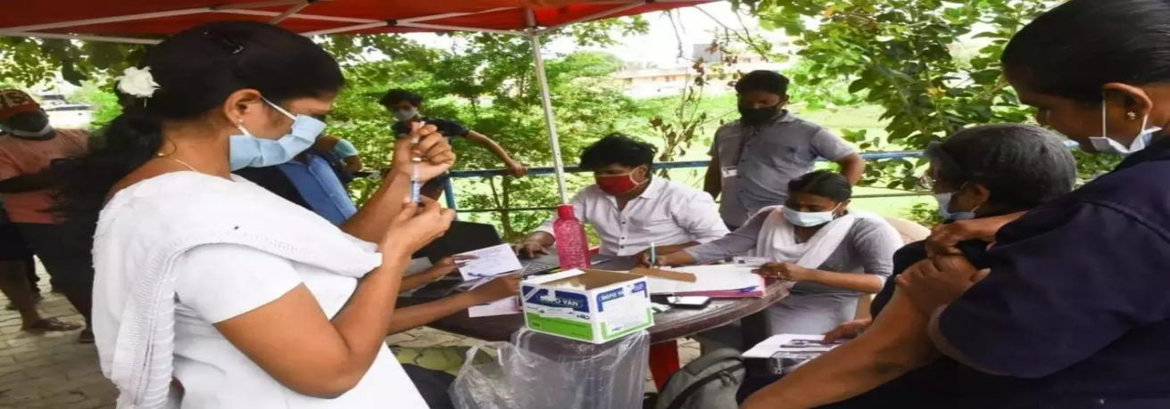 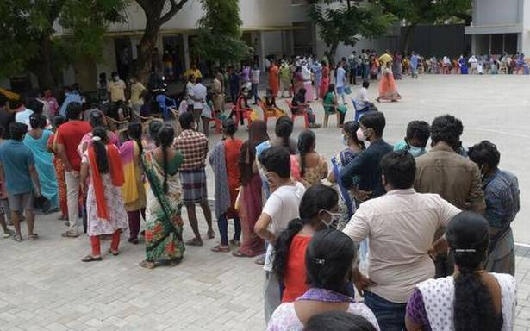

* COVID-19 Vaccine Data Systems

Tracking COVID-19 vaccine distribution and administration activities requires collaboration between public and private information technology (IT) systems and integration of existing and newly developed IT systems.

The Centers for Disease Control and Prevention (CDC) — together with federal agencies, vaccine providers, and state/local public health departments and tribal health facilities across the United States — use these data systems to inform decision-making regarding COVID-19 vaccination.

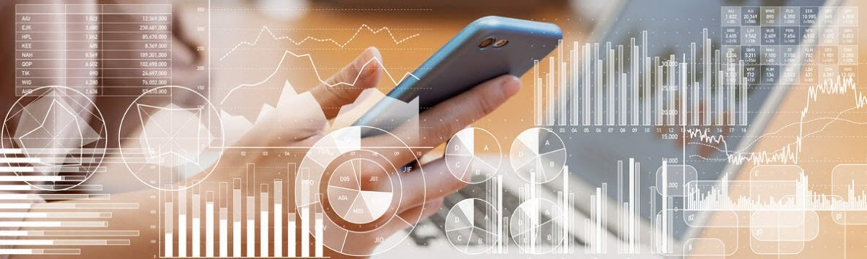

**2.2 GAPS IN EXISTING SOLUTIONS**

* Time consuming Because it will take more time to write the data in the records manually
* There may be loose of data in future,as the records may be get lost or gets damaged.
* Checking the total number of vaccinated persons in a particular area/locality is a difficult task.
* The vaccine data systems gives the information only about the vaccine count or the vaccine stock available at the particular vaccine center.
* It doesn't provide information about the person the person who got vaccinated.

1. **PROPOSED SYSTEM**

**3.1 DESCRIPTION**

Our proposed project VACCINE HANDLING SYSTEM, make the work of the volunteer or the authority more easier but speed data entry . This helps us to store and retrieve data in an efficient way. In addition to this, it also provided the information like name of the person, his age, gender, profession, Aadhaar number,mobile number, his/her body temperature, B.P, type of the vaccine he/she took, so that there will be easy retrieve of the data by using any of the above mentioned attributes. Our project is designed in such a way that each user can manage the information related to vaccine

**3.1.1 ADVANTAGES OF PROPOSED SYSTEM**

* It speedups the data entry.
* Reduces the crowd at the vaccine centers by fast data entry.
* Easy to retrieve the data.
* Time saving.
* It helps to add new record, view the available vaccine count,search for a particular tuple.

**3.2 MODULES DESCRIPTION**

Firstly, We have

* **User login :**

The user login consists of username name which is case insensitive ,password and captcha which is generated by using random function

After login we totally have 5 modules

* **ADD NEW RECORD :**

This helps us to add the details of the person who is going to get vaccinated .

This includes attributes named as

-name

-age

-gender

-profession

-body temperature

-B.P

-aadhar number

-mobile number

-type of the vaccine.

* **VIEW VACCINE :**

This module helps us to view the currently available vaccines. In addition to this it also provides the flexibilty of adding the new vaccine count.

This consists of two attributes:

-Add vaccine

-View available

* **SEARCH :**

This module helps the admin to search the data of a particular person by using the following attributes:

i)aadhar number

ii)age

iii)Gender

iv)profession

v)vaccine type

We can search/retrieve the data of the person by using any of the above mentioned attributes which make the work more easier and efficient.

* **HELP DESK :**

This consists of, the step-by-step process to implement the other modules like add new record,view vaccine ,search and saves the time and also helps the person with the execution or data entry process.

* **EXIT :**

As the name suggests,this module is used when we have completed the execution.

**3.3 REQUIREMENT SPECIFICATIONS**

**3.3.1 HARDWARE INTERFACE**

* Laptop : any company(i.e., DELL,HP,SAMSUNG...)
* Processor : Intel core i3/ Intel core i5.
* Hard Disk : 1 TB - 8 TB

**3.3.2 SOFTWARE INTERFACE**

* Platform : code blocks
* Data Base : file handling systems
* Language : C++ file coding Language

**3.4 PROPOSED SYSTEM ARCHITECTURE**

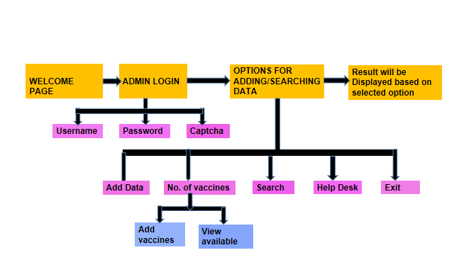

1. **UML DIAGRAM**

Login

Username

Password

Enter

Request for giving information

Add data

Add Vaccine

Search

Helpline

Exit

Admin

Patient

Add

vaccines

VaccineType

Name

Aadhaar No.

Mobile No.

Place

Gender

Profession

1. P

Temperature

By Address

By Gender

By Profession

By VaccineType

Fig: UML diagram of Vaccine handling system

1. **RESULTS AND DISCUSSION**

**MAIN CODE:**

#include<stdio.h>

#include<iostream>

#include<fstream>

#include<conio.h>

#include<string.h>

#include<algorithm>

#include<windows.h>

#include<iomanip>

#include<string>

#include<time.h>

#define num\_of\_vaccine 200

using namespace std;

int password();

void menu();

void show();

class vaccine

{

int age;

int temperature;

int blood\_pressure;

char gender;

string name;

string aadhar;

string profession;

string address;

string mobile\_number;

string stype;

int cnt;

public:

void search\_data();

void add\_new();

void setdata();

void view\_vaccine();

void showdata();

void search\_by\_aadhar();

void search\_by\_age();

void search\_by\_profession();

void search\_by\_vaccinetype();

void search\_by\_gender();

void show\_list();

void handle\_vaccine();

};

void show()

{

cout<<setw(20)<<setiosflags(ios::left)<<"Name ";

cout<<setw(20)<<"Aadhar No.";

cout<<setw(10)<<"Age";

cout<<setw(18)<<"Profession";

cout<<setw(8)<<"B.P.";

cout<<setw(15)<<"Temperature";

cout<<setw(7)<<"gender";

cout<<setw(15)<<"Mobile No.";

cout<<setw(18)<<" VaccineType ";

cout<<" Address"<<endl;

}

void vaccine ::view\_vaccine()

{

ifstream ind;

int i=0;

ind.open("vaccinetrial1.txt");

ind.seekg(0,ios::beg);

while(ind.read((char\*)this,sizeof(vaccine)))

{

i++;

}

ind.close();

int ch;

int s=num\_of\_vaccine-i;

cout<<"\n\n\t\t\xB3\xB2=\xB2=\xB2-\xB3 VACCINE HANDLING SYSTEM \xB3\xB2=\xB2=\xB2-\xB3\n\n"<<endl;

cout<<"\t\t\t\t\t\t Powered By:- CMRCET BATCH-17 "<<endl<<endl;

cout<<"\n\t\t\t\*\*\*\*\*\*\*\*\*\*\*\*\*\*\*\n";

cout<<"\t\t\t\tVACCINE STATISTICS";

cout<<"\n\t\t\t\*\*\*\*\*\*\*\*\*\*\*\*\*\*\*\n\n";

cout<<"\t\t 1. Add more \t\t\t2.View available \n\t\t\t\t\t 3. Back"<<endl;

cin>>ch;

int f\_var=0;

fstream file("count1.txt",ios::out | ios::in);

file>>f\_var;

switch(ch)

{

case 1:

int m;

cout<<"\t Enter number of vaccines you want to add "<<endl;

cin>>m;

f\_var=f\_var+m;

file.seekg(0);

file<<f\_var;

cout<<"\t\t Now total number of vaccines are : "<<f\_var+s;

break;

case 2:

cout<<"\n\nAvailable number of vaccines are "<<s+f\_var;

break;

case 3:

system("cls");

menu();

default:

system("cls");

cout<<"\nEnter valid option "<<endl;

menu();

}

file.close();

getch();

}

void vaccine::show\_list()

{

cout<<"\n";

cout<<setw(20)<<setiosflags(ios::left)<<name;

cout<<setw(20)<<aadhar;

cout<<setw(10)<<age;

cout<<setw(18)<<profession;

cout<<setw(8)<<blood\_pressure;

cout<<setw(15)<<temperature;

cout<<setw(7)<<gender;

cout<<setw(15)<<mobile\_number;

cout<<setw(18)<<stype;

cout<<address<<endl;

}

void vaccine::search\_data()

{

vaccine item;

cout<<"\n\n\t\t\xB3\xB2=\xB2=\xB2-\xB3 VACCINE HANDLING SYSTEM \xB3\xB2=\xB2=\xB2-\xB3\n\n"<<endl;

cout<<"\t\t\t\t\t\t Powered By:- CMRCET BATCH-17 "<<endl<<endl;

cout<<"\n\t\t\t\*\*\*\*\*\*\*\*\*\*\*\*\*\*\*\n";

cout<<"\t\t\t\tSEARCHING STATISTICS";

cout<<"\n\t\t\t\*\*\*\*\*\*\*\*\*\*\*\*\*\*\*\n\n";

cout<<"From which option you want to perform searching "<<endl;

cout<<"\n\t\t 1. By aadhar \t\t\t 2. By Age "<<endl;

cout<<"\n\t\t 3. By profession \t\t 4. By gender \t\t 5.By Vaccine\_Type"<<endl;

cout<<"\n\n\t\tEnter your choice ...............";

int ch;

cin>>ch;

switch(ch)

{

case 1:

system("cls");

search\_by\_aadhar();

getch();

break;

case 2:

system("cls");

search\_by\_age();

getch();

break;

case 3:

system("cls");

search\_by\_profession();

getch();

break;

case 4:

system("cls");

search\_by\_gender();

getch();

break;

case 5:

system("cls");

search\_by\_vaccinetype();

getch();

break;

default:

system("cls");

cout<<"ENTER VALID OPTION"<<endl;

menu();

}

}

void vaccine::search\_by\_aadhar()

{

ifstream in("vaccinetrial1.txt");

int flag =0;

string adh\_num;

cout<<"\n\n\t\t\xB3\xB2=\xB2=\xB2-\xB3 VACCINE HANDLING SYSTEM \xB3\xB2=\xB2=\xB2-\xB3\n\n"<<endl;

cout<<"\t\t\t\t\t\t Powered By:- CMRCET BATCH-17 "<<endl<<endl;

cout<<"\n\t\t\t\*\*\*\*\*\*\*\*\*\*\*\*\*\*\*\n";

cout<<"\t\t\t\t ADHAR SEARCHING ";

cout<<"\n\t\t\t\*\*\*\*\*\*\*\*\*\*\*\*\*\*\*\n\n";

cout<<"Enter your Aadhar number "<<endl;

fflush(stdin);

int l1=5;

while(getline(cin,adh\_num) && l1!=0){

if(adh\_num.size()==12){

break;

}

else{

l1--;

cout<<"\n\t please enter a valid aadhar number :-"<<endl;

}

}

in.read((char\*)this,sizeof(vaccine));

while(!in.eof())

{

if(adh\_num.compare(aadhar)==0)

{

showdata();

flag=1;

break;

}

in.read((char\*)this,sizeof(vaccine));

}

if(flag==0)

{

cout<<"Aadhar number not found "<<endl;

}

in.close();

}

void vaccine::search\_by\_age()

{

ifstream in("vaccinetrial1.txt");

int flag =0;

int a,p=0;

cout<<"\n\n\t\t\xB3\xB2=\xB2=\xB2-\xB3 VACCINE HANDLING SYSTEM \xB3\xB2=\xB2=\xB2-\xB3\n\n"<<endl;

cout<<"\t\t\t\t\t\t Powered By:- CMRCET BATCH-17 "<<endl<<endl;

cout<<"\n\t\t\t\*\*\*\*\*\*\*\*\*\*\*\*\*\*\*\n";

cout<<"\t\t\t\t AGE SEARCHING ";

cout<<"\n\t\t\t\*\*\*\*\*\*\*\*\*\*\*\*\*\*\*\n\n";

cout<<"enter Age by which you want to search "<<endl;

cin>>a;

// show();

in.read((char\*)this,sizeof(vaccine));

while(!in.eof())

{

if(a==age)

{

showdata();

flag=1;

p++;

}

in.read((char\*)this,sizeof(vaccine));

}

if(flag==0)

{

cout<<"Age you entered is not found"<<endl;

}

cout<<"\n\n\n\nNO of people vaccinated by this age"<<p;

in.close();

}

void vaccine::search\_by\_profession()

{

ifstream in("vaccinetrial1.txt");

int flag =0;

int p=0;

string prof;

cout<<"\n\n\t\t\xB3\xB2=\xB2=\xB2-\xB3 VACCINE HANDLING SYSTEM \xB3\xB2=\xB2=\xB2-\xB3\n\n"<<endl;

cout<<"\t\t\t\t\t\t Powered By:- CMRCET BATCH-17"<<endl<<endl;

cout<<"\n\t\t\t\*\*\*\*\*\*\*\*\*\*\*\*\*\*\*\n";

cout<<"\t\t\t\t PROFESSION SEARCHING ";

cout<<"\n\t\t\t\*\*\*\*\*\*\*\*\*\*\*\*\*\*\*\n\n";

cout<<"enter Profession by which you want to search "<<endl;

fflush(stdin);

getline(cin,prof);

show();

in.read((char\*)this,sizeof(vaccine));

while(!in.eof())

{

if(prof.compare(profession)==0)

{

show\_list();

flag=1;

p++;

}

in.read((char\*)this,sizeof(vaccine));

}

if(flag==0)

{

cout<<"The profession you have Enter does not exist"<<endl;

}

cout<<"\n\n\n NO of people vaccinated by this profession "<<p<<endl;

in.close();

}

void vaccine::search\_by\_vaccinetype()

{

ifstream in("vaccinetrial1.txt");

int flag =0;

int v=0;

string enter;

cout<<"\n\n\t\t\xB3\xB2=\xB2=\xB2-\xB3 VACCINE HANDLING SYSTEM \xB3\xB2=\xB2=\xB2-\xB3\n\n"<<endl;

cout<<"\t\t\t\t\t\t Powered By:- CMRCET BATCH-17"<<endl<<endl;

cout<<"\n\t\t\t\*\*\*\*\*\*\*\*\*\*\*\*\*\*\*\n";

cout<<"\t\t\t\t VACCINE\_TYPE SEARCHING ";

cout<<"\n\t\t\t\*\*\*\*\*\*\*\*\*\*\*\*\*\*\*\n\n";

cout<<"enter vaccine type by which you want to search "<<endl;

fflush(stdin);

getline(cin,enter);

show();

in.read((char\*)this,sizeof(vaccine));

while(!in.eof())

{

if(enter.compare(stype)==0)

{

show\_list();

flag=1;

v++;

}

in.read((char\*)this,sizeof(vaccine));

}

if(flag==0)

{

cout<<"The vaccineType you have Enter does not exist"<<endl;

}

cout<<"\n\n\n NO of people vaccinated by this VaccineType "<<v<<endl;

in.close();

}

void vaccine::search\_by\_gender()

{

ifstream in("vaccinetrial1.txt");

int flag =0;

char g;

int p=0;

cout<<"\n\n\t\t\xB3\xB2=\xB2=\xB2-\xB3 VACCINE HANDLING SYSTEM \xB3\xB2=\xB2=\xB2-\xB3\n\n"<<endl;

cout<<"\t\t\t\t\t\t Powered By:- CMRCET BATCH-17 "<<endl<<endl;

cout<<"\n\t\t\t\*\*\*\*\*\*\*\*\*\*\*\*\*\*\*\n";

cout<<"\t\t\t\t GENDER SEARCHING ";

cout<<"\n\t\t\t\*\*\*\*\*\*\*\*\*\*\*\*\*\*\*\n\n";

cout<<"Enter gender by which you want to search "<<endl;

cin>>g;

show();

in.read((char\*)this,sizeof(vaccine));

while(!in.eof())

{

if(toupper(g)==toupper(gender))

{

show\_list();

flag=1;

p++;

}

in.read((char\*)this,sizeof(vaccine));

}

if(flag==0)

{

cout<<"The gender you entered does not exist "<<endl;

}

cout<<"\n\n\n NO. of people vaccinated by this gender "<<p<<endl;

in.close();

}

void vaccine::setdata()

{

cout<<"\n\n\t\t\xB3\xB2=\xB2=\xB2-\xB3 VACCINE HANDLING SYSTEM \xB3\xB2=\xB2=\xB2-\xB3\n\n"<<endl;

cout<<"\t\t\t\t\t\t Powered By:- CMRCET BATCH-17 "<<endl<<endl;

cout<<"\n\t\t\t\*\*\*\*\*\*\*\*\*\*\*\*\*\*\*\n";

cout<<"\t\t\t\t ADDING NEW RECORD ";

cout<<"\n\t\t\t\*\*\*\*\*\*\*\*\*\*\*\*\*\*\*\n\n";

fflush(stdin);

cout<<"\n\t\t Enter your name :- ";

getline(cin,name);

cout<<"\n\t\t Enter your aadhar :- ";

int l=12;

while(getline(cin,aadhar)){

if(aadhar.size()==l){

break;

}

else{

cout<<"\n\t\t\t please enter a valid aadhar number"<<endl;

}

}

cout<<"\n\t\t Enter your gender (M|F) :- ";

cin>>gender;

cout<<"\n\t\t Enter your age:- ";

cin>>age;

fflush(stdin);

cout<<"\n\t\t Enter your profession :- ";

getline(cin,profession);

cout<<"\n\t\t Enter your B.P. :- ";

cin>>blood\_pressure;

cout<<"\n\t\t Enter your Body temperature:- ";

cin>>temperature;

fflush(stdin);

cout<<"\n\t\t Enter your permanent address :- ";

getline(cin,address);

cout<<"\n\t\t\t Enter your Mobile number :- ";

int m=10;

while(getline(cin,mobile\_number)){

if(mobile\_number.size()==m){

break;

}

else{

cout<<"\n\t\t\t please enter a valid mobile number"<<endl;

}

}

cout<<"Enter the vaccine Type :- ";

getline(cin,stype);

}

void vaccine::showdata()

{

cout<<"\n\n\t\t\xB3\xB2=\xB2=\xB2-\xB3 VACCINE HANDLING SYSTEM \xB3\xB2=\xB2=\xB2-\xB3\n\n"<<endl;

cout<<"\t\t\t\t\t\t Powered By:- CMRCET BATCH-17 "<<endl<<endl;

cout<<"\n\t\t\t\*\*\*\*\*\*\*\*\*\*\*\*\*\*\*\n";

cout<<"\t\t\t\t DETAILS ";

cout<<"\n\t\t\t\*\*\*\*\*\*\*\*\*\*\*\*\*\*\*\n\n";

cout<<"\t\t Name is: "<<name<<endl;

cout<<"\t\t Aadhar number is: "<<aadhar<<endl;

cout<<"\t\t Your age is "<<age<<endl;

cout<<"\t\t Profession is : "<<profession<<endl;

cout<<"\t\t VaccineType is : "<<stype<<endl;

cout<<"\t\t Gender is : "<<gender<<endl;

cout<<"\t\t Blood pressure is :"<<blood\_pressure<<endl;

cout<<"\t\t Body temperature is : "<<temperature<<endl;

cout<<"\t\t Address is "<<address<<endl;

cout<<"\t\t Mobile number is: "<<mobile\_number<<endl;

}

void vaccine::add\_new()

{

fstream outin;

outin.open("vaccinetrial1.txt",ios::app|ios::in);

setdata();

outin.write((char\*)this,sizeof(vaccine));

cout<<"YOUR DATA HAS BEEN SUCCESSFULLY INSERTED "<<endl;

getch();

outin.close();

}

void vaccine::handle\_vaccine(){

cout<<"\n\n\t\t\xB3\xB2=\xB2=\xB2-\xB3 IF THERE IS ANY NEED OR HELP WE ARE HERE \xB3\xB2=\xB2=\xB2-\xB3\n\n"<<endl;

cout<<"---> FIRSTLY THERE IS AN LOGIN PAGE DESIGNED FOR ADMINS WHO CAN HAVE AN SECURITY FOR THERE DATA"<<endl;

cout<<"---> THE NEXT PAGE EXPLAINS ABOUT THE DIFFERENT ATTRIBUTES OR FEATURES OF THE PROJECT"<<endl;

cout<<"---> AS THE ADMINS PREFERNCE THE INDIVIDUAL ATTRIBUTES WILL BE WORKING WHERE AS \n\t\t --> THERE ARE DIFFERENT ATTRIBUTES\n\t\t\t 1.ADD DATA\n\t\t\t\t WE CAN ADD DATA BY THE DIFFERENT FORM DETAILS THAT INCLUDES NAME, ADDHAR NO, GENDER, PHONE NO, BP etc\n\t\t\t 2. VIEW DATA :\n\t\t\t\t THIS CONSIST OF DETAILED INFORMATION ABOUT THE VACCINES DATA SUCH AS ADD VACCINES ,VIEW STATUS , VIEW AVAILABILTY etc..\n\t\t\t 3. SEARCH :\n\t\t\t\t IT GIVES THE DIFFERENT WAYS TO SEARCH THE DETAILS OF VACCINES BY USING FEILDS SUCH AS BY ADDAHR, BY AGE, BY GENDER, BY PROFFESION...\n\t\t\t 4 HELP DESK,5 EXIT : THIS TWO ARE GENERAL OPTIONS USED IN ANY HELP AND LEAVE THE EXECTION BY SELECTING EXIT()\n\n\n\n\n\n\n\n\n\n\n\t\t\t\t\t\t\t \*\*\*\*\*\*THANK YOU\*\*\*\*\*\*\n\t\t \n\t\t "<<endl;

getch();

}

void menu()

{

system("cls");

cout<<"\n\n\t\t\xB3\xB2=\xB2=\xB2-\xB3 VACCINE HANDLING SYSTEM \xB3\xB2=\xB2=\xB2-\xB3\n\n"<<endl;

cout<<"\t\t\t\t\t\t Powered By:- CMRCET BATCH-17 "<<endl<<endl;

cout<<"\n\t\t\t\*\*\*\*\*\*\*\*\*\*\*\*\*\*\*\n";

cout<<"\t\t\t\t\tMENU";

cout<<"\n\t\t\t\*\*\*\*\*\*\*\*\*\*\*\*\*\*\*\n";

cout<<"\n\t\t1: Add NEW Record\t\t\t 2: View VACCINE DATA"<<endl;

cout<<"\n\t\t3: search \t\t\t\t 4: Help desk \t\t\t\t 5: exit"<<endl;

}

int main()

{

vaccine obj;

int k=3;

int num\_vac;

cout<<"\n\n\t\t\xB3\xB2=\xB2=\xB2-\xB3 VACCINE HANDLING SYSTEM \xB3\xB2=\xB2=\xB2-\xB3\n\n"<<endl;

cout<<"\t\t\t\t\t\t Powered By:- CMRCET BATCH-17 "<<endl;

cout<<"\t\n\n Press any key to continue............. "<<endl;

getch();

B:

system("cls");

cout<<"\n\n\t\t\t\t\*\*\*\*\*\*\*\*\*\*\*\*\*\*\*\*\*";

cout<<"\n\t\t\t\t\tEnter User name and Password\n";

cout<<"\t\t\t\t\*\*\*\*\*\*\*\*\*\*\*\*\*\*\*\*\*\n";

while(k>=1)

{

int c = password();

if(c==1)

break;

else

cout<<"\n\n\t\t Wrong Password Or User Name \n\n\t\t You Can try Only "<<k-1<<" times more";

k--;

if(k<1)

{

for(int i=59; i>=0; i--)

{

system("cls");

cout<<"\n\n\n\n\n\n\n\n\t\t\t\t\tYOU ARE BLOCKED FOR 1 MINUTE!!";

cout<<"\n\n\n\n\n\n\t\t\t\t\tTRY AFTER "<<i<<" SECONDS.....";

Sleep(1000);

}

k=3;

goto B;

}

}

int ch;

do{

cout<<"\n\n\t\t\xB3\xB2=\xB2=\xB2-\xB3 VACCINE HANDLING SYSTEM \xB3\xB2=\xB2=\xB2-\xB3\n\n"<<endl;

cout<<"\t\t\t\t\t\t Powered By:- CMRCET BATCH-17 "<<endl;

menu();

cout<<"\n\t\n\tChoose according to your need : ";

cin>>ch;

vaccine v1;

switch(ch)

{

case 1: system("cls");

obj.add\_new();

break;

case 2: system("cls");

obj.view\_vaccine();

break;

case 3:system("cls");

obj.search\_data();

break;

case 4: system("cls");

obj.handle\_vaccine();

break;

case 5: system("cls");

exit(0);

default: system("cls");

cout<<"\n\n\n\n\n\n\n\n\t\t\t\t\t\tTHANK YOU!!";

cout<<"\n\n\t\t\t\t\t\*\*\*HAVE A NICE DAY\*\*";

Sleep(3000);

exit(0);

}

}while(ch!=0);

return 0;

}

int password()

{

char pass[20];

char cname[30];

int ch, i=0,cap=0,capt=0;

cout<<"\n\n\n\n\n\t\t\t\t\tUSER NAME: ";

fflush(stdin);

cin>>cname;

for(int i=0;i<sizeof(cname);i++){

if(cname[i]>=97){

cname[i]=cname[i]-32;

}

}

cout<<"\n\t\t\t\t\tPASSWORD: ";

while((ch=getch()) != 13)

{

cout<<"\*";

pass[i]=ch;

i++;

}

pass[i] = '\0';

srand(time(0));

cap=rand();

cout<<"\n\t\t\t\t\t CAPTURE:-> "<<cap<<endl<<endl;

cout<<" Please enter the valid capture :- ";

cin>>capt;

if( (strcmp(cname,"CMRCET")==0) && (strcmp(pass,"1234")==0) && cap==capt)

return 1;

else

return 0;

}

* 1. **EXECUTION SCREENS:**

**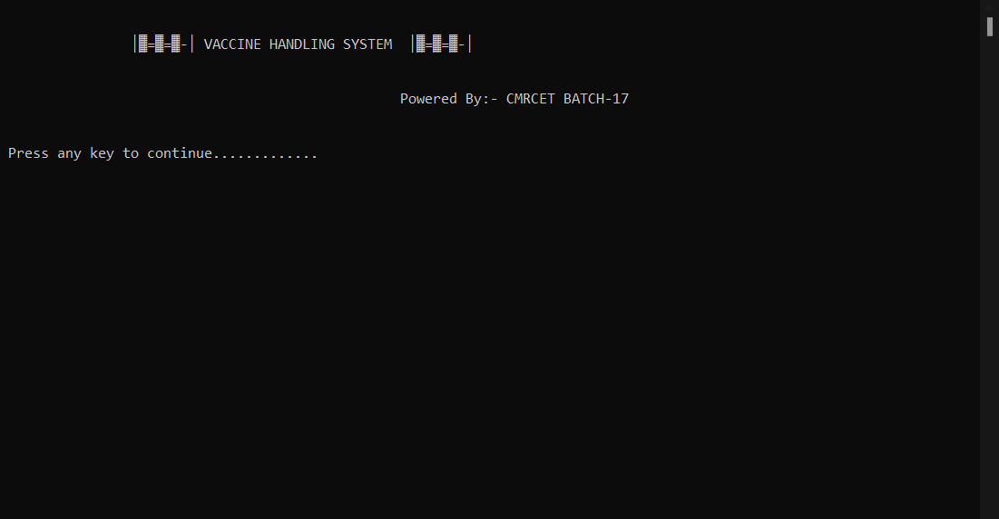**

FIG:1 Welcome page

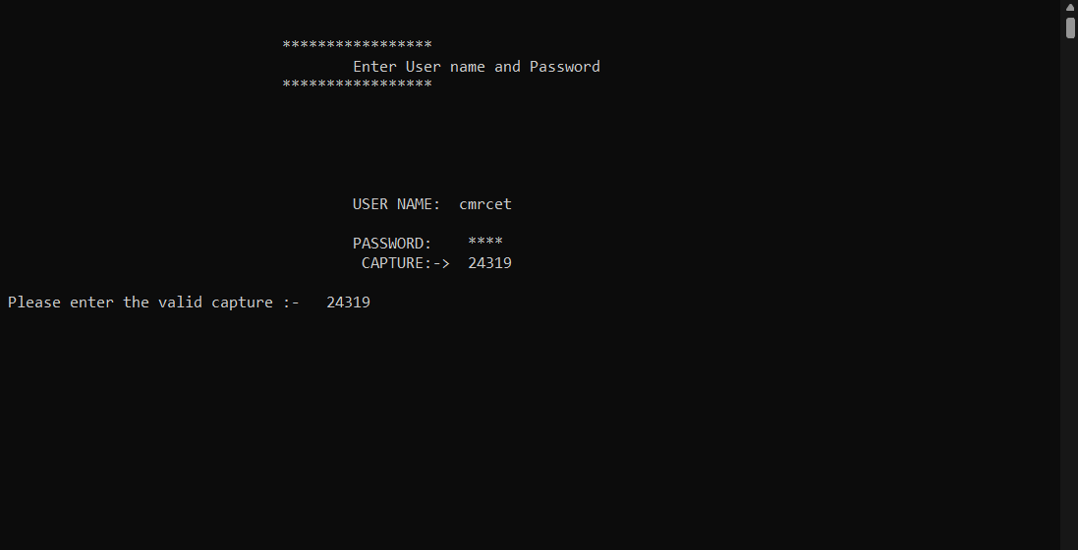

FIG:2 User login

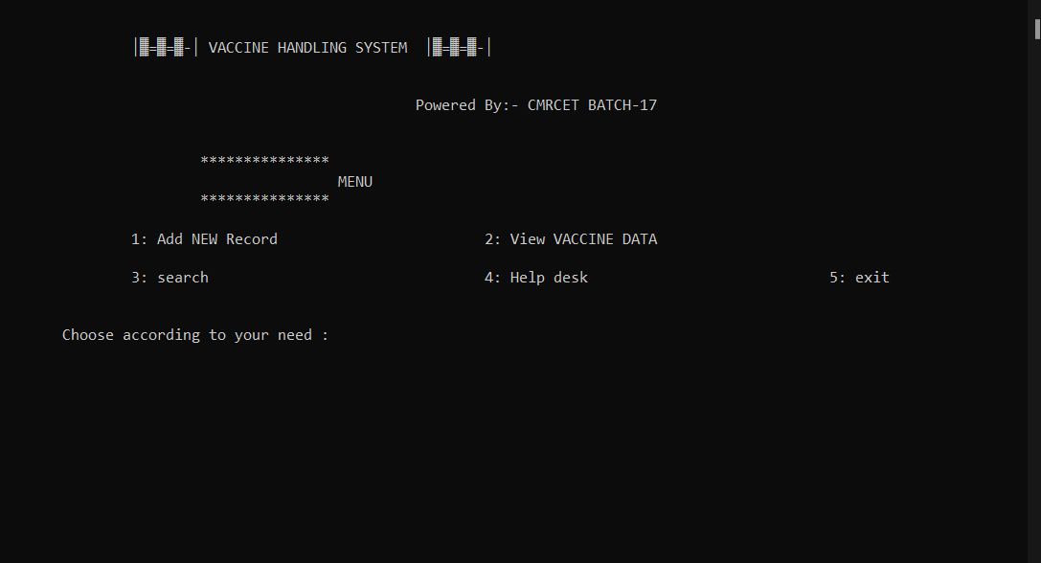

FIG:3 Displaying Modules

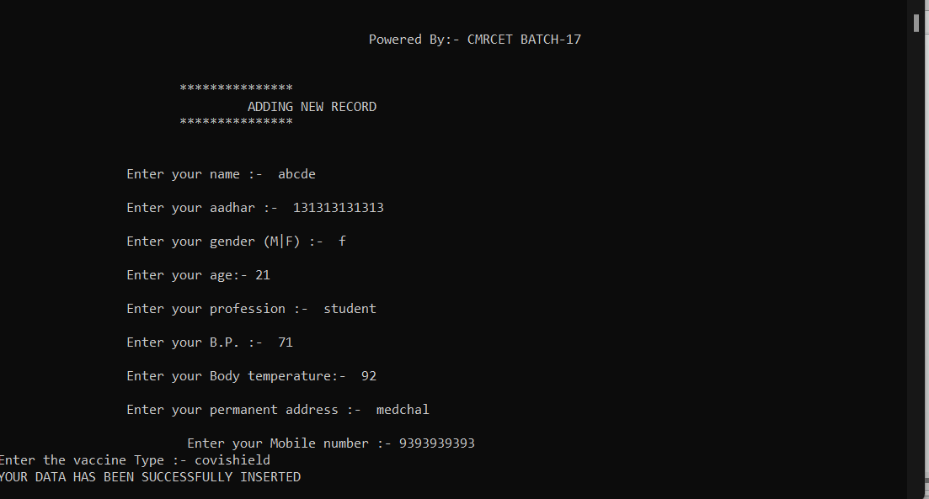

FIG:4 Adding new record

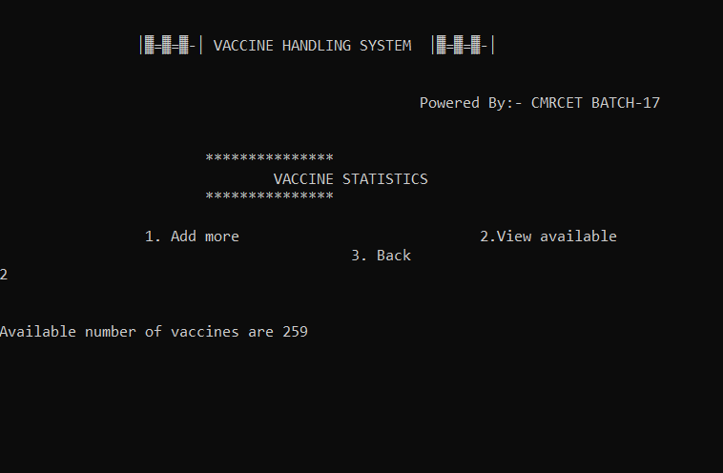

FIG:5 View Available Vaccines

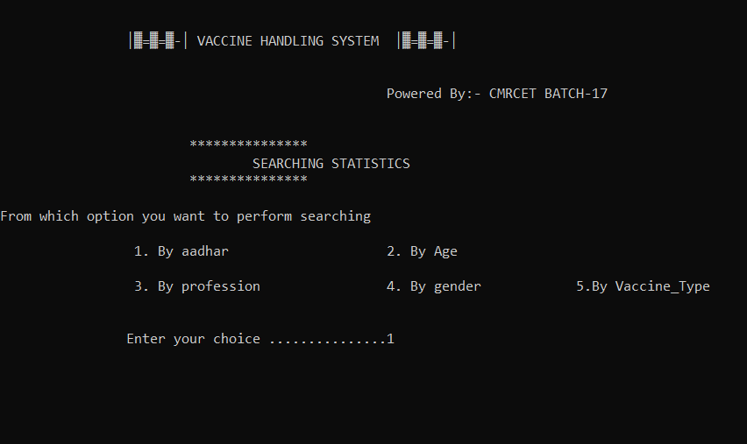

FIG:6 Searching data

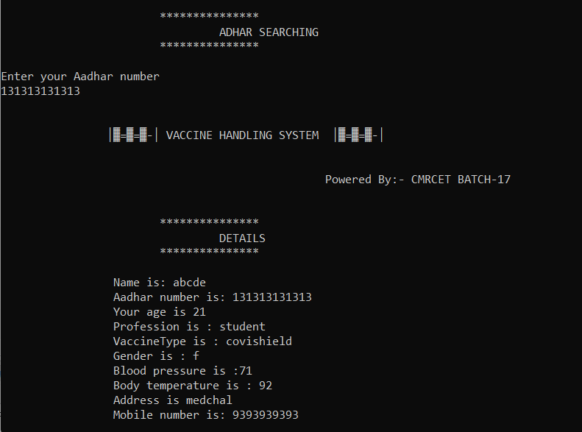

FIG:7 Searching data by aadhar number

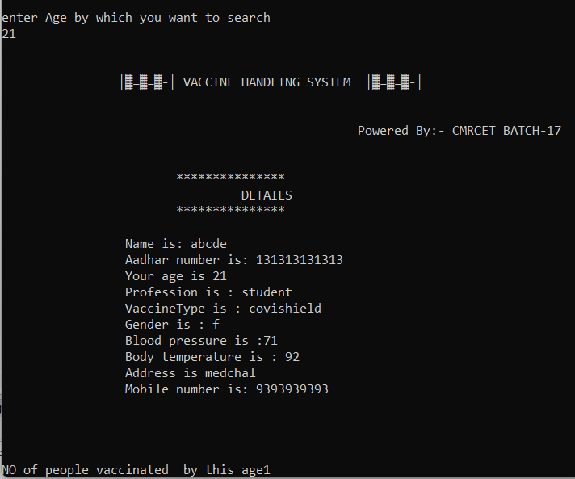

FIG:8 Searching data by Age

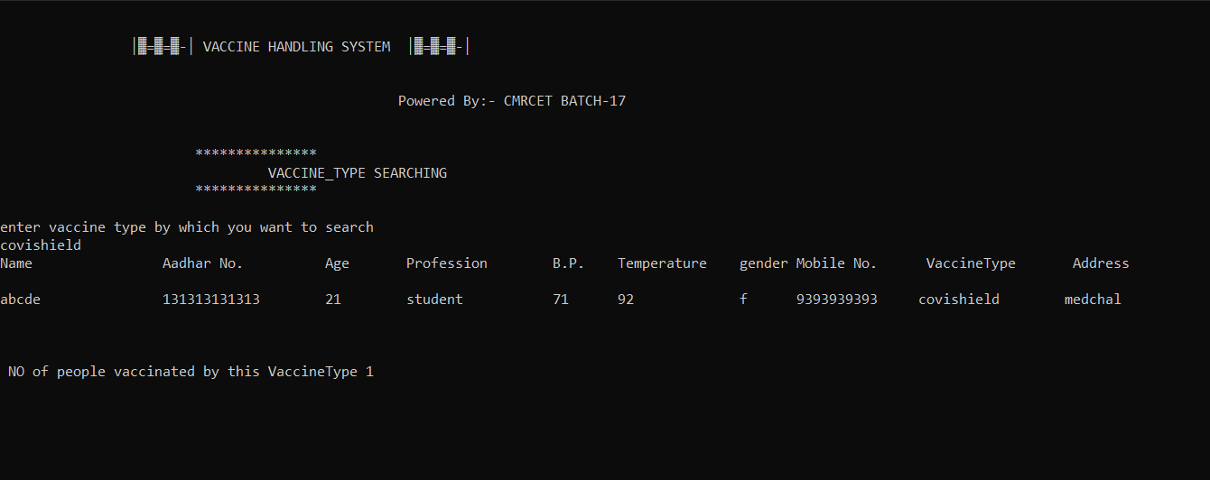

FIG:9 Searching data by Vaccine type

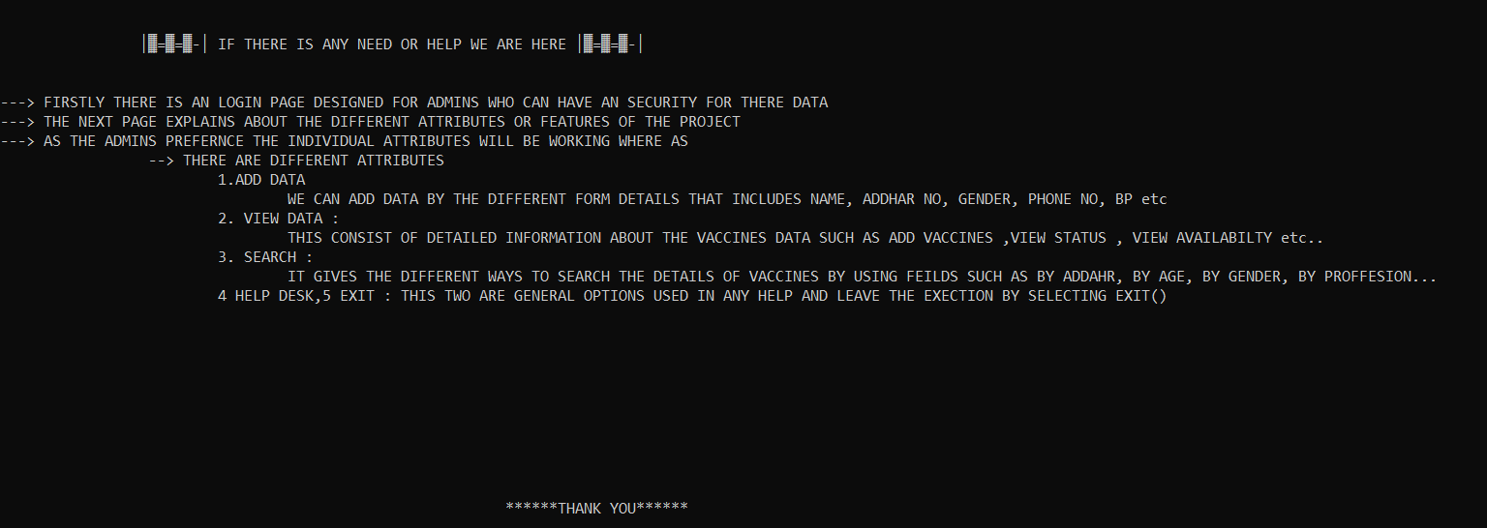

FIG:10 Help Desk

1. **CONCLUSION**

We want to conclude that ,we built our project by using the code block platform and C++ coding language so that it will be easier to correct if any error occurs. It is very efficient project that includes the addition of person details who got vaccinated. In addition to this, our project also provides the total count of the available vaccines. As our data is only admin accessible we have created an username and password so that no one can access to the data. we also added the captcha section for additional security.

1. **REFERENCES**

* [https://www.who.int/health-topics/coronavirus](https:/www.who.int/health-topics/coronavirus)
* [https://www-outlookindia-com.cdn.ampproject.org/v/s/www.outlookindia.com/photosamp/topic/covid-19-vaccine/107434?amp\_js\_v=a6&amp\_gsa=1&usqp=mq331AQKKAFQArABIIACAw%3D%3D#aoh=16388905273070&referrer=https%3A%2F%2Fwww.google.com&amp\_tf=From%20%251%24s&ampshar](https:/www-outlookindia-com.cdn.ampproject.org/v/s/www.outlookindia.com/photosamp/topic/covid-19-vaccine/107434?amp_js_v=a6&amp_gsa=1&usqp=mq331AQKKAFQArABIIACAw%3D%3D" \l "aoh=16388905273070&referrer=https%3A%2F%2Fwww.google.com&amp_tf=From%20%251%24s&ampsha)
* <https://www.cdc.gov/vaccines/covid-19/reporting/index.html>
* [https://rebellionvoice.com/wp-content/uploads/2021/04/klb02-hgp-covid-dry-run-051-938758-1610610479.jpg](https:/rebellionvoice.com/wp-content/uploads/2021/04/klb02-hgp-covid-dry-run-051-938758-1610610479.jpg)